**Assignment No 4**

**Sameer Joshi**

**Task:** Create a Registration form in the application using Bootstrap. Create input fields Name, Mobile Number, Email Id and Password. Create buttons in the form for Reset and Submit.

Create a login form using Bootstrap. Create input fields Email Id and Password, and Login button.

Use Bootstrap form controls to set the size of input text fields. Add validation states using Bootstrap. Attach glyphicons to the input fields.

Create a table using Bootstrap in Products page with columns Product Id, Product Name, Description and Price. Customize the styling of Bootstrap table using SASS.

**Codes:**

**Home Page:**

**index.html**

<!doctype html>

<html lang="en">

  <head>

    <meta charset="utf-8">

    <meta name="viewport" content="width=device-width, initial-scale=1, shrink-to-fit=no">

    <meta name="description" content="">

    <meta name="author" content="Mark Otto, Jacob Thornton, and Bootstrap contributors">

    <meta name="generator" content="Jekyll v4.1.1">

    <link rel="canonical" href="https://getbootstrap.com/docs/4.5/examples/navbar-fixed/">

    <!-- Bootstrap core CSS -->

<link href="style/bootstrap.min.css" rel="stylesheet">

    <style>

      .bd-placeholder-img {

        font-size: 1.125rem;

        text-anchor: middle;

        -webkit-user-select: none;

        -moz-user-select: none;

        -ms-user-select: none;

        user-select: none;

      }

      @media (min-width: 768px) {

        .bd-placeholder-img-lg {

          font-size: 3.5rem;

        }

      }

    </style>

    <!-- Custom styles for this template -->

    <link rel="stylesheet" href="style/style.css">

    <link href="style/css/all.css" rel="stylesheet">

  </head>

  <body>

    <nav class="navbar navbar-expand-md navbar-inverse fixed-top bg-inverse">

  <a class="navbar-brand" href="#"><i class="fab fa-shopify"></i> Shopper's Stop</a>

  <button class="navbar-toggler" type="button" data-toggle="collapse" data-target="#navbarCollapse" aria-controls="navbarCollapse" aria-expanded="false" aria-label="Toggle navigation">

    <span class="navbar-toggler-icon"></span>

  </button>

  <div class="collapse navbar-collapse" id="navbarCollapse">

    <ul class="navbar-nav mr-auto">

      <li class="nav-item active">

        <a class="nav-link" href="index.html">Home <span class="sr-only">(current)</span></a>

      </li>

      <li class="nav-item">

        <a class="nav-link" href="shopping.html">Shopping</a>

      </li>

      <li class="nav-item">

        <a class="nav-link" href="product.html">Products</a>

      </li>

      <li class="nav-item" id="login">

        <a class="btn btn-aqua" href="login.html">Login</a>

      </li>

      <li class="nav-item" id="register">

        <a class="btn btn-aqua m-auto" href="register.html">Register</a>

      </li>

    </ul>

  </div>

</nav>

<main role="main" class="container">

    <div>

        <p>

            <span style="font-size:60px;">You are here</span><br><br>

            <span style="font-size:30px;">This is biggest Shopping website in India. <br><br>

            We Offer You thousands of technical products.<br><br>

            From Earphone to Air conditionor You can find Everything here<br></span>

        </p>

    </div>

</main>

<script src="https://code.jquery.com/jquery-3.5.1.slim.min.js" integrity="sha384-DfXdz2htPH0lsSSs5nCTpuj/zy4C+OGpamoFVy38MVBnE+IbbVYUew+OrCXaRkfj" crossorigin="anonymous"></script>

      <script>window.jQuery || document.write('<script src="assets/js/vendor/jquery.slim.min.js"><\/script>')</script><script src="assets/dist/js/bootstrap.bundle.min.js"></script>

      </body>

</html>

**Login Page**

**login.html**

<!doctype html>

<html lang="en">

  <head>

    <meta charset="utf-8">

    <meta name="viewport" content="width=device-width, initial-scale=1, shrink-to-fit=no">

    <meta name="description" content="">

    <meta name="author" content="Mark Otto, Jacob Thornton, and Bootstrap contributors">

    <meta name="generator" content="Jekyll v4.1.1">

    <link rel="canonical" href="https://getbootstrap.com/docs/4.5/examples/navbar-fixed/">

    <script src="js/register.js"></script>

    <!-- Bootstrap core CSS -->

<link href="style/bootstrap.min.css" rel="stylesheet">

    <style>

      .bd-placeholder-img {

        font-size: 1.125rem;

        text-anchor: middle;

        -webkit-user-select: none;

        -moz-user-select: none;

        -ms-user-select: none;

        user-select: none;

      }

      @media (min-width: 768px) {

        .bd-placeholder-img-lg {

          font-size: 3.5rem;

        }

      }

    </style>

    <!-- Custom styles for this template -->

    <link rel="stylesheet" href="style/style.css">

    <link href="style/css/all.css" rel="stylesheet">

  </head>

  <body>

    <nav class="navbar navbar-expand-md navbar-inverse fixed-top bg-inverse">

        <a class="navbar-brand" href="index.html"><i class="fab fa-shopify"></i> Shopper's Stop</a>

        <button class="navbar-toggler" type="button" data-toggle="collapse" data-target="#navbarCollapse" aria-controls="navbarCollapse" aria-expanded="false" aria-label="Toggle navigation">

          <span class="navbar-toggler-icon"></span>

        </button>

        <div class="collapse navbar-collapse" id="navbarCollapse">

          <ul class="navbar-nav mr-auto">

            <li class="nav-item active">

              <a class="nav-link" href="index.html">Home <span class="sr-only">(current)</span></a>

            </li>

            <li class="nav-item">

              <a class="nav-link" href="shopping.html">Shopping</a>

            </li>

            <li class="nav-item">

              <a class="nav-link" href="product.html">Products</a>

            </li>

            <li class="nav-item" id="login">

              <a class="btn btn-aqua m-auto" href="register.html">Register</a>

            </li>

          </ul>

        </div>

      </nav>

<main role="main" class="container">

    <div class="container">

        <div class="row">

            <div class="col-md-6">

                <div class="form-box">

                    <h3>Log In</h3>

                    <form action="#" class="needs-validation" id="log">

                        <div class="form-group" id="main">

                            <label class="form-control-label form-control-lg">E-mail</label>

                            <input type="email" class="form-control" id="email" placeholder="Please enter your e-mail address" data-fv-notempty="true">

                            <div class="form-control-feedback" id="correct">Your Email is correct</div>

                            <div class="form-control-feedback" id="wrong">Please Enter valid email</div>

                          </div><!-- .form-group -->

                        <div class="form-group">

                            <label class="form-control-label form-control-lg">Password</label>

                            <input type="password" class="form-control" data-fv-notempty="true">

                        </div><!-- .form-group -->

                        <div class="form-group">

                              <button class="btn btn-purple" onclick="return validateForm()">Log In</button>

                        </div><!-- .form-group -->

                      </form>

                  </div><!-- .form-box -->

            </div><!-- .col-md-6 -->

</main>

<script src="https://code.jquery.com/jquery-3.5.1.slim.min.js" integrity="sha384-DfXdz2htPH0lsSSs5nCTpuj/zy4C+OGpamoFVy38MVBnE+IbbVYUew+OrCXaRkfj" crossorigin="anonymous"></script>

      <script>window.jQuery || document.write('<script src="assets/js/vendor/jquery.slim.min.js"><\/script>')</script><script src="assets/dist/js/bootstrap.bundle.min.js"></script>

</html>

**Registration Page**

**register.html**

<!doctype html>

<html lang="en">

  <head>

    <meta charset="utf-8">

    <meta name="viewport" content="width=device-width, initial-scale=1, shrink-to-fit=no">

    <meta name="description" content="">

    <meta name="author" content="Mark Otto, Jacob Thornton, and Bootstrap contributors">

    <meta name="generator" content="Jekyll v4.1.1">

    <link rel="canonical" href="https://getbootstrap.com/docs/4.5/examples/navbar-fixed/">

    <!-- Bootstrap core CSS -->

<link href="style/bootstrap.min.css" rel="stylesheet">

    <style>

      .bd-placeholder-img {

        font-size: 1.125rem;

        text-anchor: middle;

        -webkit-user-select: none;

        -moz-user-select: none;

        -ms-user-select: none;

        user-select: none;

      }

      @media (min-width: 768px) {

        .bd-placeholder-img-lg {

          font-size: 3.5rem;

        }

      }

    </style>

    <!-- Custom styles for this template -->

    <link rel="stylesheet" href="style/style.css">

    <link href="style/css/all.css" rel="stylesheet">

    <script src="js/register.js"></script>

  </head>

  <body>

    <nav class="navbar navbar-expand-md navbar-inverse fixed-top bg-inverse">

        <a class="navbar-brand" href="index.html"><i class="fab fa-shopify"></i> Shopper's Stop</a>

        <button class="navbar-toggler" type="button" data-toggle="collapse" data-target="#navbarCollapse" aria-controls="navbarCollapse" aria-expanded="false" aria-label="Toggle navigation">

          <span class="navbar-toggler-icon"></span>

        </button>

        <div class="collapse navbar-collapse" id="navbarCollapse">

          <ul class="navbar-nav mr-auto">

            <li class="nav-item active">

              <a class="nav-link" href="index.html">Home <span class="sr-only">(current)</span></a>

            </li>

            <li class="nav-item">

              <a class="nav-link" href="shopping.html">Shopping</a>

            </li>

            <li class="nav-item">

              <a class="nav-link" href="product.html">Products</a>

            </li>

            <li class="nav-item" id="login">

              <a class="btn btn-aqua" href="login.html">Login</a>

            </li>

          </ul>

        </div>

      </nav>

<main role="main" class="container">

    <div class="container">

        <div class="row">

            <div class="col-md-6">

                <div class="form-box">

                    <h3>Create an account</h3>

                    <form action="#" id="register">

                        <div class="form-group" id="mname">

                            <label class="form-control-label">Your name</label>

                            <input type="text" class="form-control" placeholder="Please enter your full name" data-fv-notempty="true" id="name">

                            <div class="form-control-feedback" id="correctname">Your Name is correct</div>

                          <div class="form-control-feedback" id="wrongname">Please Enter valid Name</div>

                        </div><!-- .form-group -->

                        <div class="form-group" id="no">

                            <label class="form-control-label">Mobile Number</label>

                            <input type="Number" class="form-control" placeholder="Please enter your mobile number" data-fv-notempty="true" id="mno">

                            <div class="form-control-feedback" id="correctno">Your Number is correct</div>

                          <div class="form-control-feedback" id="wrongno">Please Enter valid Number</div>

                        </div><!-- .form-group -->

                        <div class="form-group" id="main">

                          <label class="form-control-label form-control-lg">E-mail</label>

                          <input type="email" class="form-control" id="email" placeholder="Please enter your e-mail address" data-fv-notempty="true" id="email">

                          <div class="form-control-feedback" id="correctmail">Your Email is correct</div>

                          <div class="form-control-feedback" id="wrongmail">Please Enter valid email</div>

                        </div><!-- .form-group -->

                        <div class="form-group">

                            <label class="form-control-label">Password</label>

                            <input type="password" class="form-control" data-fv-notempty="true">

                        </div><!-- .form-group -->

                        <div class="form-group buttons">

                              <button class="btn btn-purple" onclick="return registerValidation()">Submit</button>

                              <button class="btn btn-purple">Clear</button>

                        </div><!-- .form-group -->

                      </form>

                  </div><!-- .form-box -->

            </div><!-- .col-md-6 -->

</main>

<script src="https://code.jquery.com/jquery-3.5.1.slim.min.js" integrity="sha384-DfXdz2htPH0lsSSs5nCTpuj/zy4C+OGpamoFVy38MVBnE+IbbVYUew+OrCXaRkfj" crossorigin="anonymous"></script>

      <script>window.jQuery || document.write('<script src="assets/js/vendor/jquery.slim.min.js"><\/script>')</script><script src="assets/dist/js/bootstrap.bundle.min.js"></script>

</html>

**Products page**

**product.html**

<!doctype html>

<html lang="en">

  <head>

    <meta charset="utf-8">

    <meta name="viewport" content="width=device-width, initial-scale=1, shrink-to-fit=no">

    <meta name="description" content="">

    <meta name="author" content="Mark Otto, Jacob Thornton, and Bootstrap contributors">

    <meta name="generator" content="Jekyll v4.1.1">

    <link rel="canonical" href="https://getbootstrap.com/docs/4.5/examples/navbar-fixed/">

    <!-- Bootstrap core CSS -->

<link href="style/bootstrap.min.css" rel="stylesheet">

    <style>

      .bd-placeholder-img {

        font-size: 1.125rem;

        text-anchor: middle;

        -webkit-user-select: none;

        -moz-user-select: none;

        -ms-user-select: none;

        user-select: none;

      }

      @media (min-width: 768px) {

        .bd-placeholder-img-lg {

          font-size: 3.5rem;

        }

      }

    </style>

    <!-- Custom styles for this template -->

    <link href="style/css/all.css" rel="stylesheet">

    <link rel="stylesheet" href="style/style.css">

  </head>

  <body>

    <nav class="navbar navbar-expand-md navbar-inverse fixed-top bg-inverse">

  <a class="navbar-brand" href="index.html"><i class="fab fa-shopify"></i> Shopper's Stop</a>

  <button class="navbar-toggler" type="button" data-toggle="collapse" data-target="#navbarCollapse" aria-controls="navbarCollapse" aria-expanded="false" aria-label="Toggle navigation">

    <span class="navbar-toggler-icon"></span>

  </button>

  <div class="collapse navbar-collapse" id="navbarCollapse">

    <ul class="navbar-nav mr-auto">

      <li class="nav-item active">

        <a class="nav-link" href="index.html">Home <span class="sr-only">(current)</span></a>

      </li>

      <li class="nav-item">

        <a class="nav-link" href="shopping.html">Shopping</a>

      </li>

      <li class="nav-item">

        <a class="nav-link" href="product.html">Products</a>

      </li>

      <li class="nav-item" id="login">

        <a class="btn btn-aqua" href="login.html">Login</a>

      </li>

      <li class="nav-item" id="register">

        <a class="btn btn-aqua m-auto" href="register.html">Register</a>

      </li>

    </ul>

  </div>

</nav>

<main role="main" class="container">

    <div class="container">

        <div class="row">

            <div class="col-md-12">

                <table class="table table-bordered table-hover table-responsive">

                    <thead class="thead-inverse">

                      <tr>

                        <th>#</th>

                        <th>Product Id</th>

                        <th>Product Name</th>

                        <th>Description</th>

                        <th>Price</th>

                      </tr>

                    </thead>

                    <tbody>

                      <tr>

                        <td>1</td>

                        <td>K618</td>

                        <td>Asus Rog</td>

                        <td>3 year Warranty.</td>

                        <td>45000</td>

                      </tr>

                      <tr>

                        <td>2</td>

                        <td>M312</td>

                        <td>Asus Fallen</td>

                        <td>1 year Warranty.</td>

                        <td>48000</td>

                      </tr>

                      <tr>

                        <td>3</td>

                        <td>7656</td>

                        <td>HP 7656</td>

                        <td>2 year Warranty.</td>

                        <td>40000</td>

                      </tr>

                      <tr>

                        <td>4</td>

                        <td>SJ12</td>

                        <td>Lenovo Legend</td>

                        <td>2 year Warranty.</td>

                        <td>41000</td>

                      </tr>

                      <tr>

                        <td>5</td>

                        <td>S3M3</td>

                        <td>Predator Rog</td>

                        <td>3 year Warranty.</td>

                        <td>72000</td>

                      </tr>

                      <tr>

                        <td>6</td>

                        <td>M416</td>

                        <td>Dell M416</td>

                        <td>2 year Warranty.</td>

                        <td>45000</td>

                      </tr>

                    </tbody>

                </table>

            </div><!-- .col-md-12 -->

        </div><!-- .row -->

    </div><!-- .container -->

</main>

<script src="https://code.jquery.com/jquery-3.5.1.slim.min.js" integrity="sha384-DfXdz2htPH0lsSSs5nCTpuj/zy4C+OGpamoFVy38MVBnE+IbbVYUew+OrCXaRkfj" crossorigin="anonymous"></script>

      <script>window.jQuery || document.write('<script src="assets/js/vendor/jquery.slim.min.js"><\/script>')</script><script src="assets/dist/js/bootstrap.bundle.min.js"></script>

      </body>

</html>

**Shopping Page**

**shopping.html**

<!DOCTYPE html>

<html>

    <head>

        <link rel="stylesheet" href="style/bootstrap.min.css">

        <link rel="stylesheet" href="style/style.css">

        <link href="https://fonts.googleapis.com/css?family=Roboto:300,400,500" rel="stylesheet">

        <link rel="stylesheet" href="style/css/all.css">

    </head>

    <body>

      <nav class="navbar navbar-expand-md navbar-inverse fixed-top bg-inverse">

        <a class="navbar-brand" href="index.html"><i class="fab fa-shopify"></i> Shopper's Stop</a>

        <button class="navbar-toggler" type="button" data-toggle="collapse" data-target="#navbarCollapse" aria-controls="navbarCollapse" aria-expanded="false" aria-label="Toggle navigation">

          <span class="navbar-toggler-icon"></span>

        </button>

        <div class="collapse navbar-collapse" id="navbarCollapse">

          <ul class="navbar-nav mr-auto">

            <li class="nav-item active">

              <a class="nav-link" href="index.html">Home <span class="sr-only">(current)</span></a>

            </li>

            <li class="nav-item">

              <a class="nav-link" href="shopping.html">Shopping</a>

            </li>

            <li class="nav-item">

              <a class="nav-link" href="product.html">Products</a>

            </li>

            <li class="nav-item" id="login">

              <a class="btn btn-aqua" href="login.html">Login</a>

            </li>

            <li class="nav-item" id="register">

              <a class="btn btn-aqua m-auto" href="register.html">Register</a>

            </li>

          </ul>

        </div>

      </nav>

      <div class="place-list">

            <div class="container">

                <div class="row">

                    <div class="col-md-9 push-md-3">

                        <div class="row">

                            <div class="col-sm-6 col-md-6 col-lg-4 order-last">

                                <div class="card">

                                    <img class="card-img-top" src="Images/l1.jfif" alt="Place 1">

                                    <div class="card-block">

                                        <h4 class="card-title">Dell M416</h4>

                                        <p class="card-text"><i class="fas fa-tags"></i> 45000<br>Warranty: 2 Years<br></p>

                                        <a href="#" class="btn btn-green">BUY <i class="fas fa-shopping-cart"></i></a>

                                    </div><!-- .card-block -->

                                </div><!-- .card -->

                            </div><!-- .col-md-4 -->

                            <div class="col-sm-6 col-md-6 col-lg-4">

                                <div class="card">

                                    <img class="card-img-top" src="Images/l2.jfif" alt="Place 1">

                                    <div class="card-block">

                                        <h4 class="card-title">Asus K618</h4>

                                        <p class="card-text"><i class="fas fa-tags"></i> 45000<br>Warranty: 3 Years<br></p>

                                            <a href="#" class="btn btn-green">BUY <i class="fas fa-shopping-cart"></i></span></a>

                                    </div><!-- .card-block -->

                                </div><!-- .card -->

                            </div><!-- .col-md-4 -->

                            <div class="col-sm-6 col-md-6 col-lg-4">

                                <div class="card">

                                    <img class="card-img-top" src="Images/l3.jfif" alt="Place 1">

                                    <div class="card-block">

                                        <h4 class="card-title">Asus M312</h4>

                                        <p class="card-text"><i class="fas fa-tags"></i> 48000<br>Warranty: 1 Years<br></p>

                                        <a href="#" class="btn btn-green">BUY <i class="fas fa-shopping-cart"></i></a>

                                    </div><!-- .card-block -->

                                </div><!-- .card -->

                            </div><!-- .col-md-4 -->

                            <div class="col-sm-6 col-md-6 col-lg-4">

                                <div class="card">

                                    <img class="card-img-top" src="Images/l4.jfif" alt="Place 1">

                                    <div class="card-block">

                                        <h4 class="card-title">Lenovo SJ12</h4>

                                        <p class="card-text"><i class="fas fa-tags"></i> 41000<br>Warranty: 2 Years<br></p>

                                        <a href="#" class="btn btn-green">BUY <i class="fas fa-shopping-cart"></i></a>

                                    </div><!-- .card-block -->

                                </div><!-- .card -->

                            </div><!-- .col-md-4 -->

                            <div class="col-sm-6 col-md-6 col-lg-4">

                                <div class="card">

                                    <img class="card-img-top" src="Images/l5.jfif" alt="Place 1">

                                    <div class="card-block">

                                        <h4 class="card-title">HP 7656</h4>

                                        <p class="card-text"><i class="fas fa-tags"></i> 40000<br>Warranty: 2 Years<br></p>

                                        <a href="#" class="btn btn-green">BUY <i class="fas fa-shopping-cart"></i></a>

                                    </div><!-- .card-block -->

                                </div><!-- .card -->

                            </div><!-- .col-md-4 -->

                            <div class="col-sm-6 col-md-6 col-lg-4">

                                <div class="card">

                                    <img class="card-img-top" src="Images/l6.jfif" alt="Place 1">

                                    <div class="card-block">

                                        <h4 class="card-title">Predator S3M3</h4>

                                        <p class="card-text"><i class="fas fa-tags"></i> 72000<br>Warranty: 3 Years<br></p>

                                        <a href="#" class="btn btn-green">BUY <i class="fas fa-shopping-cart"></i></a>

                                    </div><!-- .card-block -->

                                </div><!-- .card -->

                            </div><!-- .col-md-4 -->

                        </div><!-- .row -->

                    </div><!-- .col-md-9 -->

                    <div class="col-md-3 pull-md-9">

                        <ul class="list-group">

                            <a href="#" class="list-group-item active">Laptops <i class="fas fa-laptop"></i></a>

                            <a href="#" class="list-group-item list-group-item-action">Mobile Devices <i class="fas fa-mobile"></i></a>

                            <a href="#" class="list-group-item list-group-item-action">Tabs <i class="fas fa-tablet"></i></a>

                            <a href="#" class="list-group-item list-group-item-action">Accessories <i class="fas fa-keyboard"></i></a>

                            <a href="#" class="list-group-item list-group-item-action">Connectibles<i class="fas fa-wifi"></i></a>

                        </ul>

                    </div><!-- .col-md-3 -->

                </div><!-- .row -->

            </div><!-- .container -->

        </div><!-- .place-list -->

        <div>

            <div>

                <footer>Created By Sameer Joshi</footer>

            </div>

        </div>

        <script src="https://code.jquery.com/jquery-3.5.1.slim.min.js" integrity="sha384-DfXdz2htPH0lsSSs5nCTpuj/zy4C+OGpamoFVy38MVBnE+IbbVYUew+OrCXaRkfj" crossorigin="anonymous"></script>

        <script>window.jQuery || document.write('<script src="assets/js/vendor/jquery.slim.min.js"><\/script>')</script><script src="assets/dist/js/bootstrap.bundle.min.js"></script>

        <script src="js/tether.min.js"></script>

        <script src="js/jquery.site.js"></script>

        <script src="js/bootstrap.min.js"></script>

      </body>

</html>

**Layout file**

**layout.scss**

@import "../modules/mixins.scss";

@import "../modules/variables.scss";

@import "../partials/nav.scss";

@import "../partials/product.scss";

@import "../partials/products.scss";

@import "../partials/register.scss";

@import "..//partials/shopping.scss";

@import "../partials/gridcontent.scss";

**partial file for grid**

**gridcontent.scss**

.place-list {

    .card {

        text-align: center;

        margin-bottom: 20px;

        border: 1px solid grey;

        background-color: gray;

    }

    .btn-green {

        display: block;

        border: 1px solid purple;

        background: transparent;

        color: purple;

        &:hover {

            background: purple;

            color: #fff;

        }

    }

}

**partial file for navbar**

**nav.scss**

/* Show it is fixed to the top */

body {

    min-height: 75rem;

    padding-top: 4.5rem;

  }

  .btn-aqua {

    display: block;

    border: 1px solid $nav-button-color;

    background: transparent;

    color:$nav-button-color;

  }

  .nav-link:hover{

    background-color: rgb(72, 156, 177);

  }

  .btn-aqua:hover{

    @extend .nav-link:hover;

  }

  #login{

    margin-right: 20px;

    margin-left: 10px;

  }

**partial file for product**

**product.scss**

.table thead th {

    font-weight: $head-and-cols-weight;

    text-transform: uppercase;

}

products.scss

.place-list {

    .card {

        text-align: center;

        margin-bottom: 20px;

        border: 1px solid grey;

        background-color: rgb(206, 176, 176);

    }

    .btn-green {

        display: block;

        border: 1px solid $card-button-color;

        background: transparent;

        color: $card-button-color;

        &:hover {

            background: $card-button-color;

            color: #fff;

        }

        @include changer(lg) {

            overflow: hidden;

            text-overflow: ellipsis;

        }

        @include changer(sm) {

            overflow: hidden;

            text-overflow: ellipsis;

        }

    }

}

**partial file for forms**

**form.scss**

.form-box {

    overflow: hidden;

    padding: 20px;

    background: #f7f7f9;

    h3 {

        font-size: 36px;

        list-style: 48px;

        font-weight: $head-and-cols-weight;

    }

    p {

        color: #636c72;

    }

    .btn-green {

        font-size: 18px;

        line-height: 27px;

    }

    .form-group:last-child {

        margin-top: 1.5rem;

    }

}

.form-group {

    margin-bottom: 1.5rem;

}

.form-control-label {

    font-weight: $head-and-cols-weight;

}

.form-control {

    line-height: 1.8rem;

}

.btn-purple{

    display: block;

    border: 1px solid $card-button-color;

    background: transparent;

    color:$card-button-color;

    &:hover{

        background-color: $card-button-color;

        color:white

    }

}

.buttons{

    display: inline-flex;

    .btn{

        margin-left: 10px;

        margin-right: 10px;

    }

}

#correct,#wrong{

    display:none;

}

#correctname,#wrongname,#correctno,#wrongno,#correctmail,#wrongmail{

    display:none;

}

**partial file for shopping**

**shopping.scss**

.shopper{

    display: inline-flex;

    margin-top:100px;

    .value{

        padding:40px;

        text-align: center;

        font-size: 20px;

        }

}

**Mixins file**

**mixins.scss**

@mixin changer($size) {

    @if $size == xs {

        @media (max-width: 576px) {

            @content;

        }

    }

    @else if $size == sm {

        @media (min-width: 576px) and (max-width: 768px) {

            @content;

        }

    }

    @else if $size == md {

        @media (min-width: 768px) and (max-width: 992px) {

            @content;

        }

    }

    @else if $size == lg {

        @media (min-width: 992px) and (max-width: 1200px) {

            @content;

        }

    }

    @else if $size == xl {

        @media (min-width: 1200px) {

            @content;

        }

    }

}

**variables.scss**

$card-button-color:purple;

$nav-button-color:aqua;

$head-and-cols-weight:bold;

**Outputs/Screenshots**

**Home page**

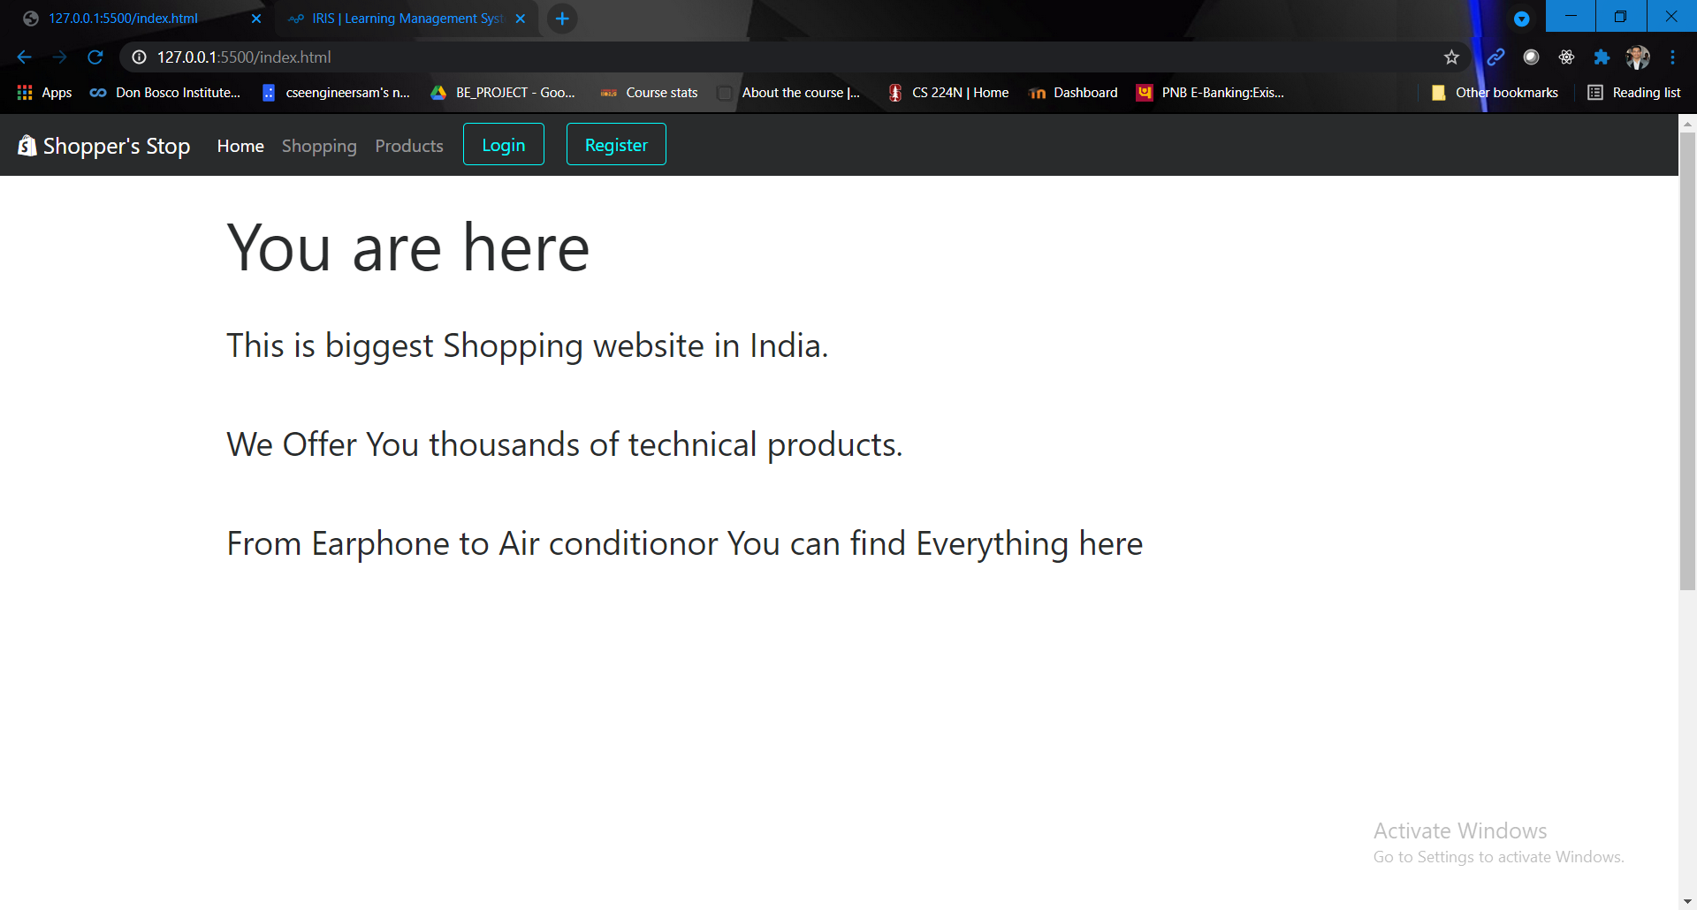

**Login Page**

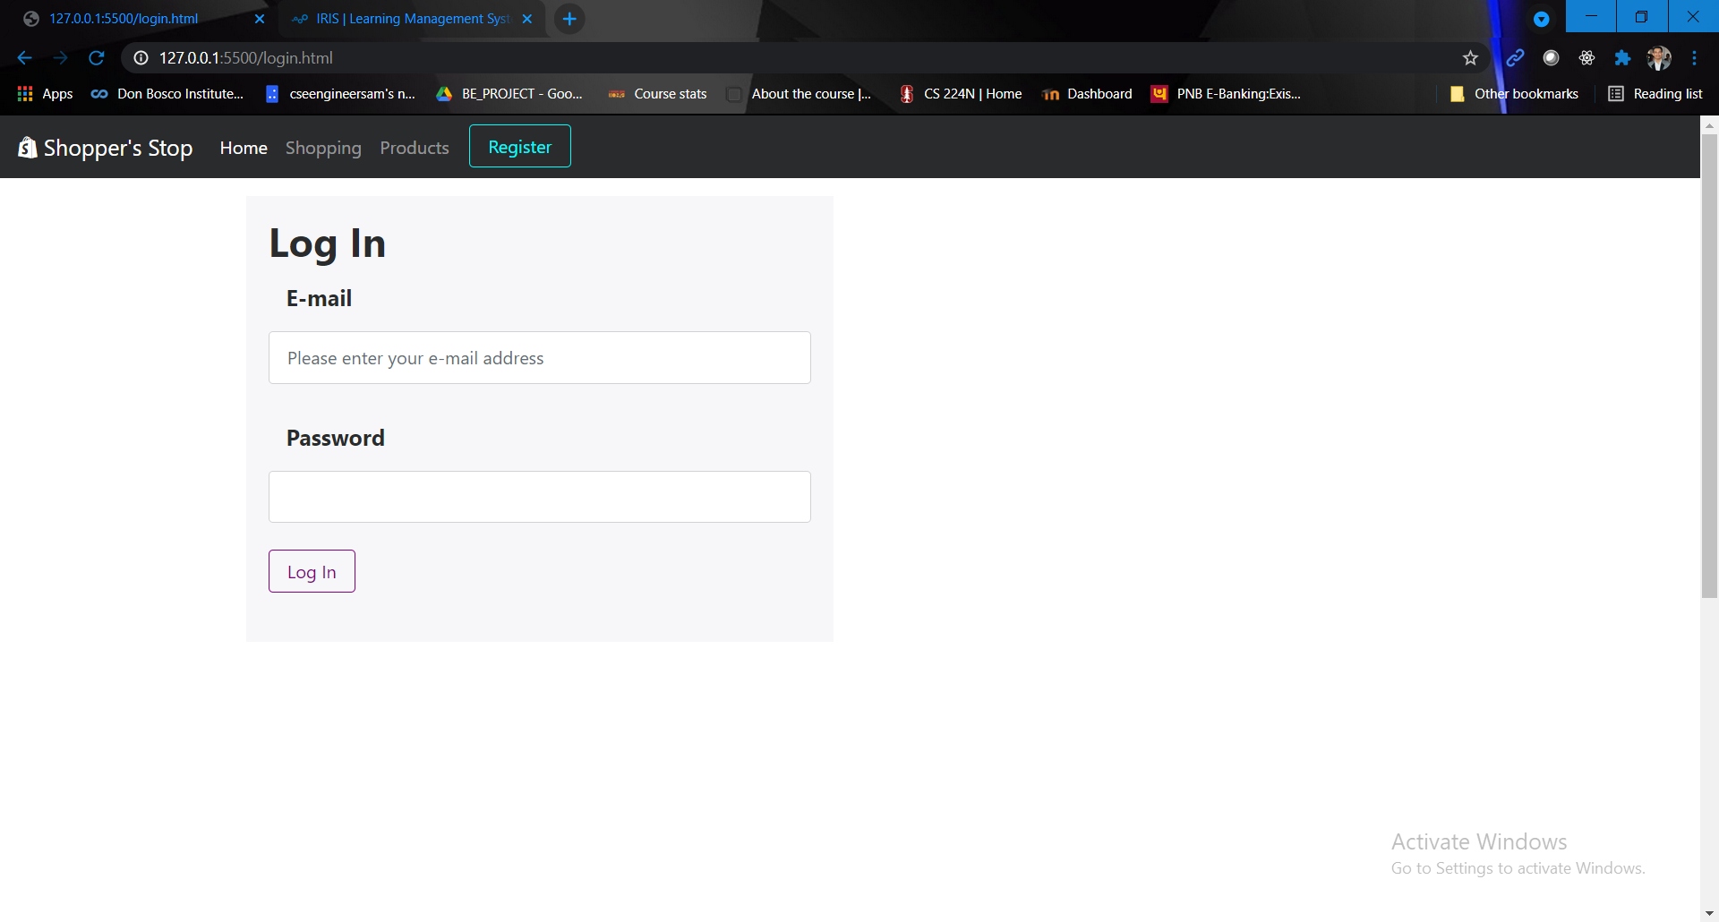

**Login Form validation with glyph icons**

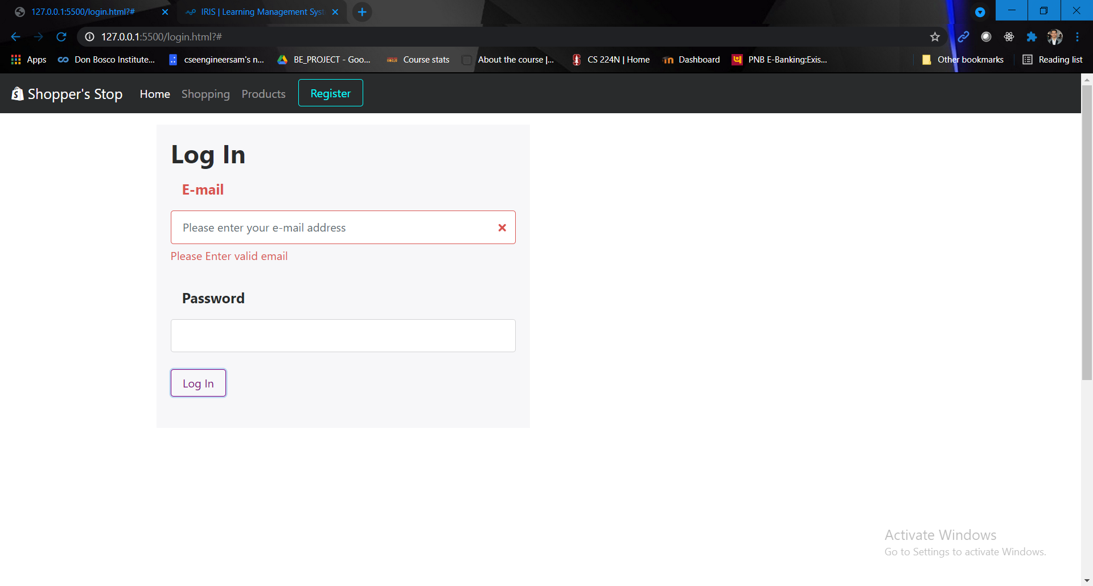

**Registration form**

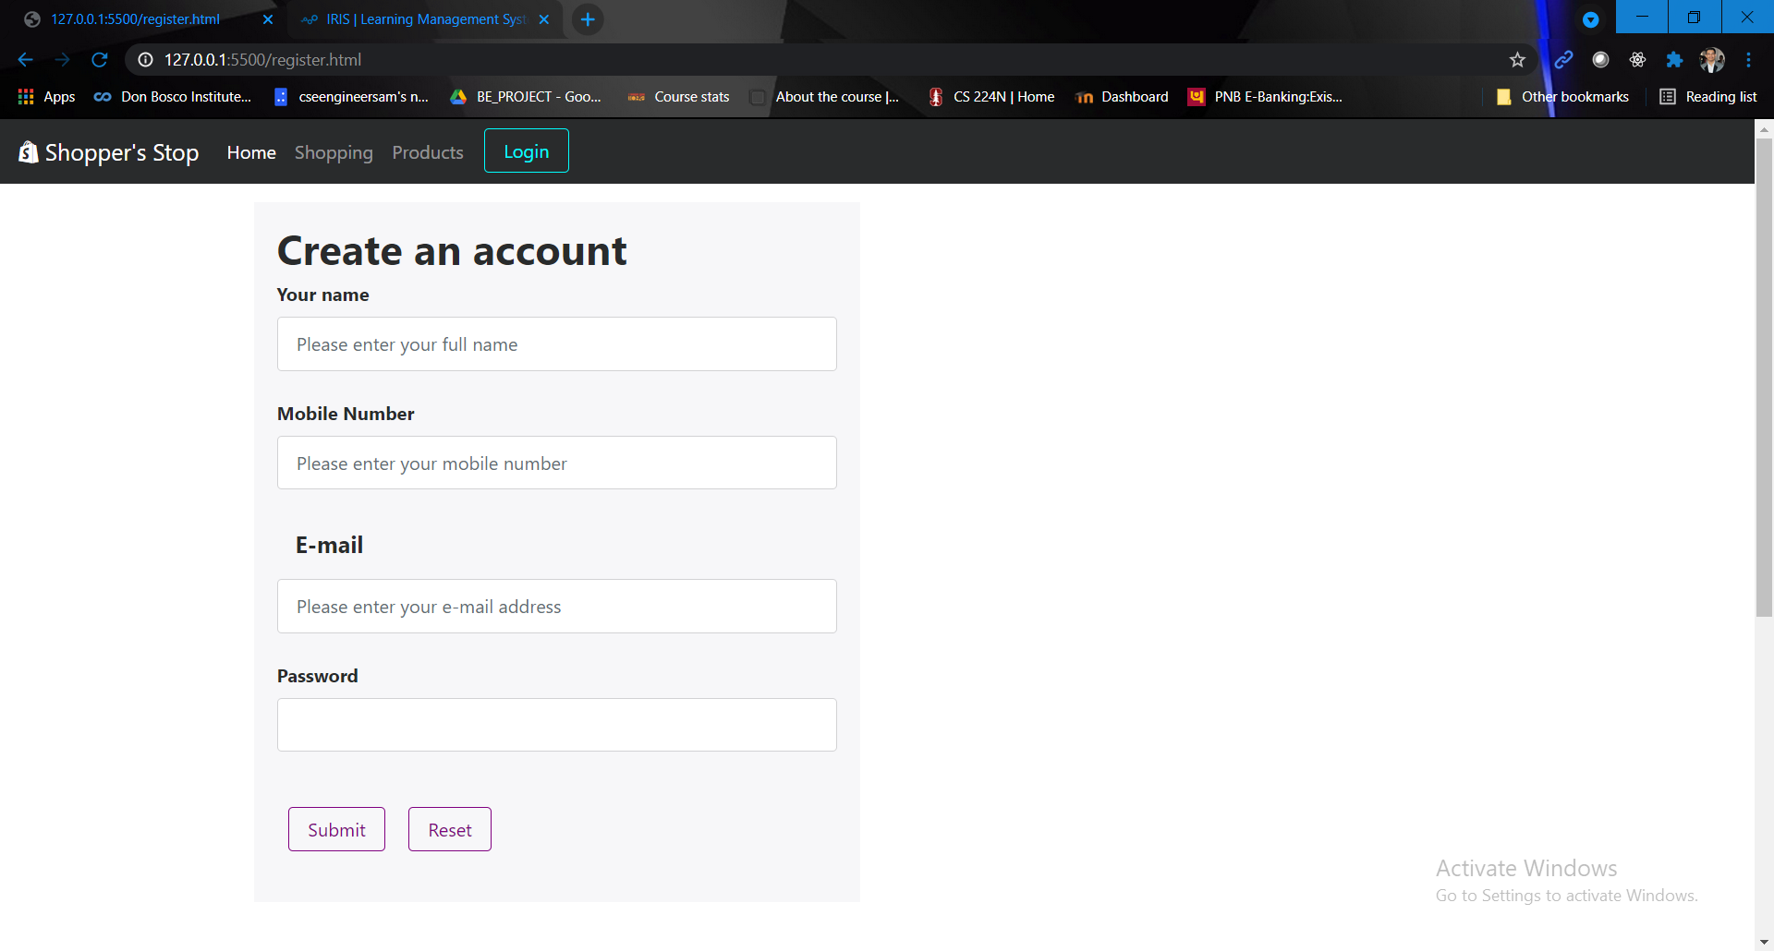

**Registration form validation using glyph icons**

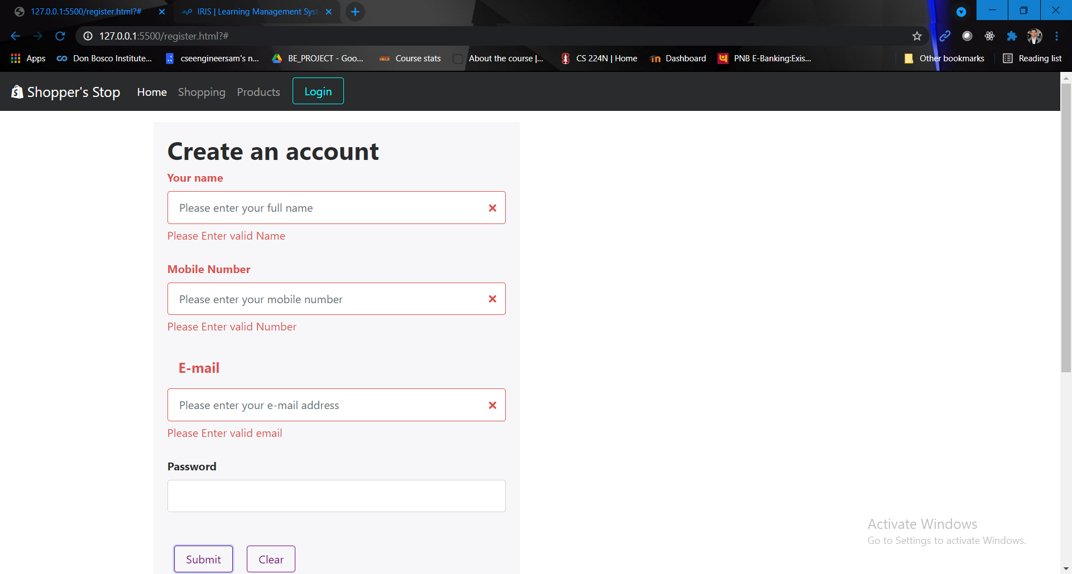

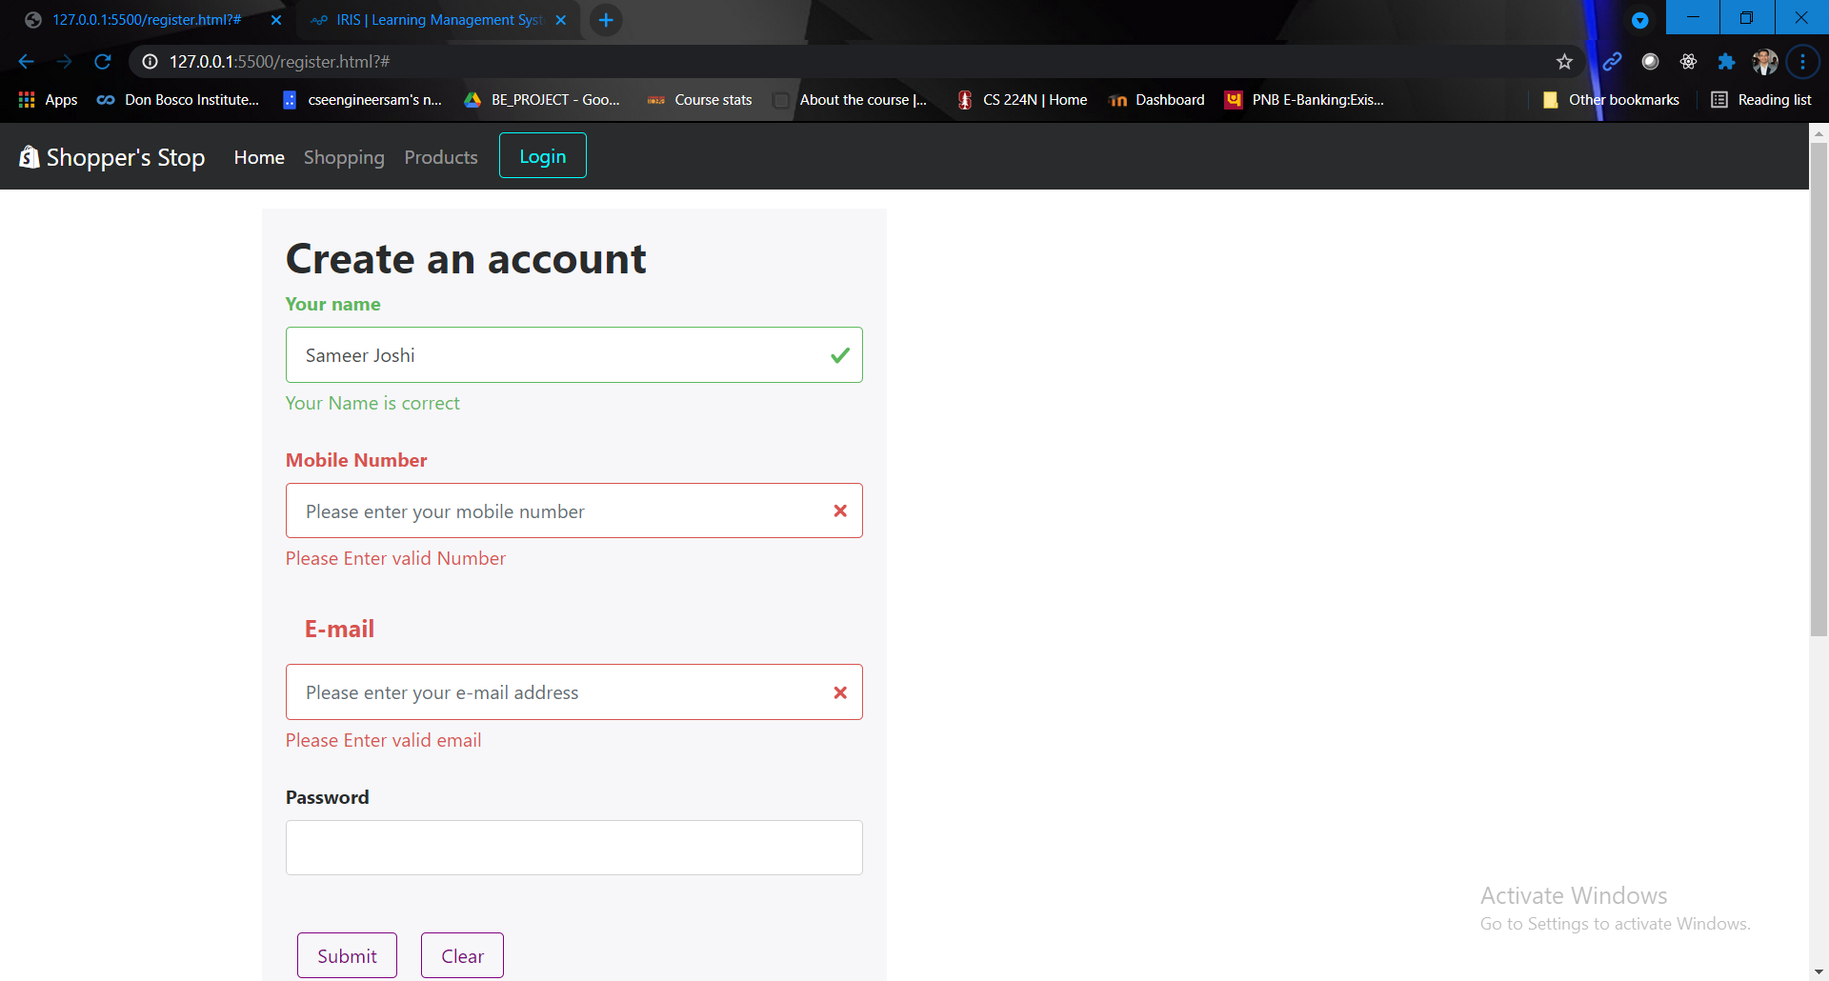

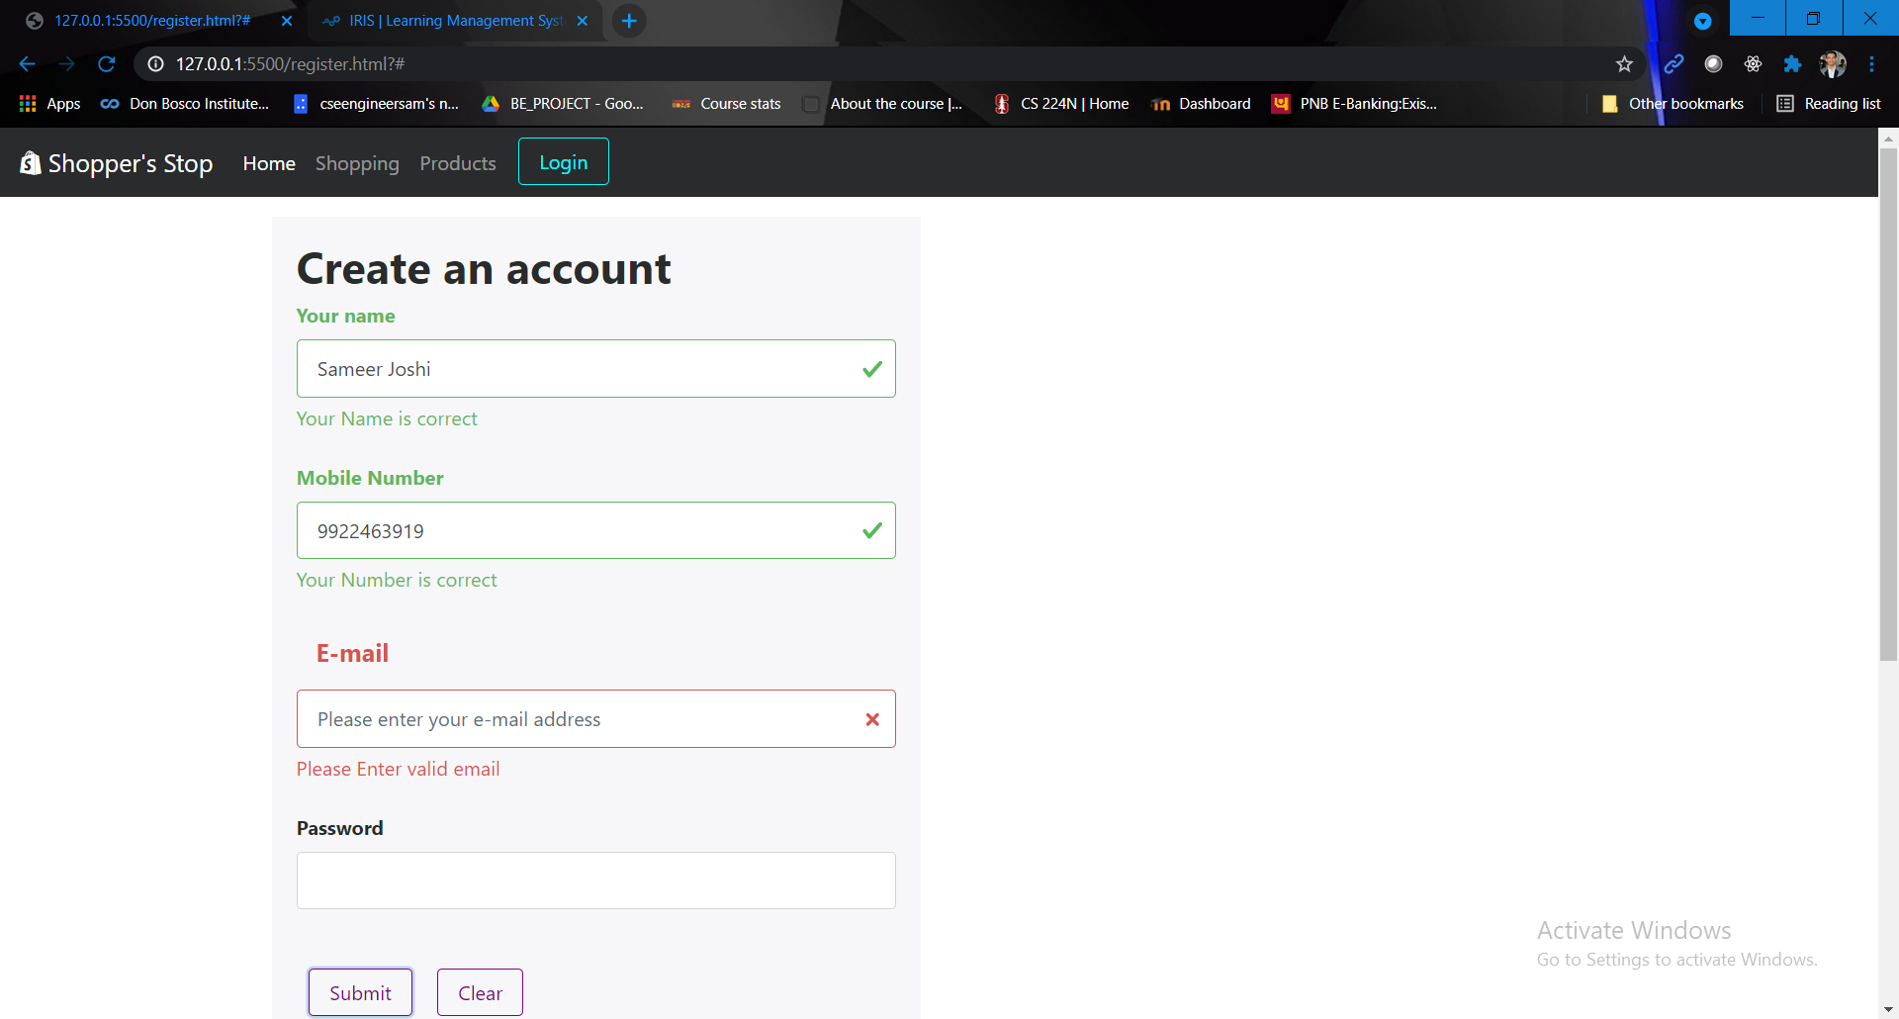

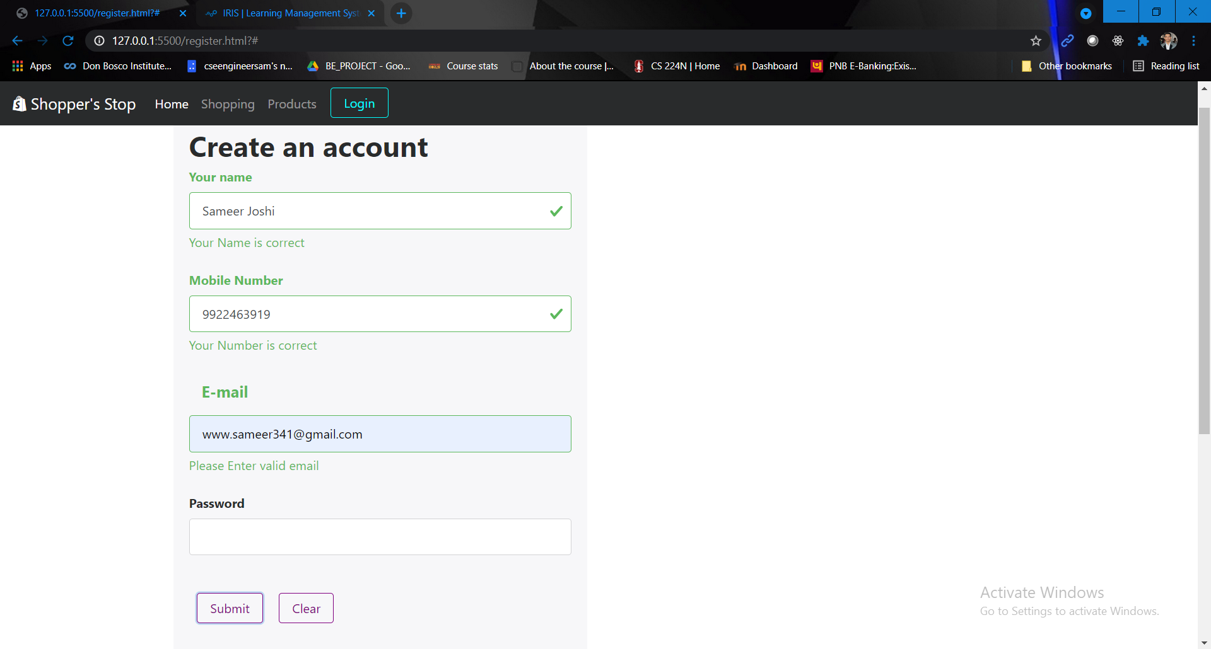

**Shopping page with glyph icons**

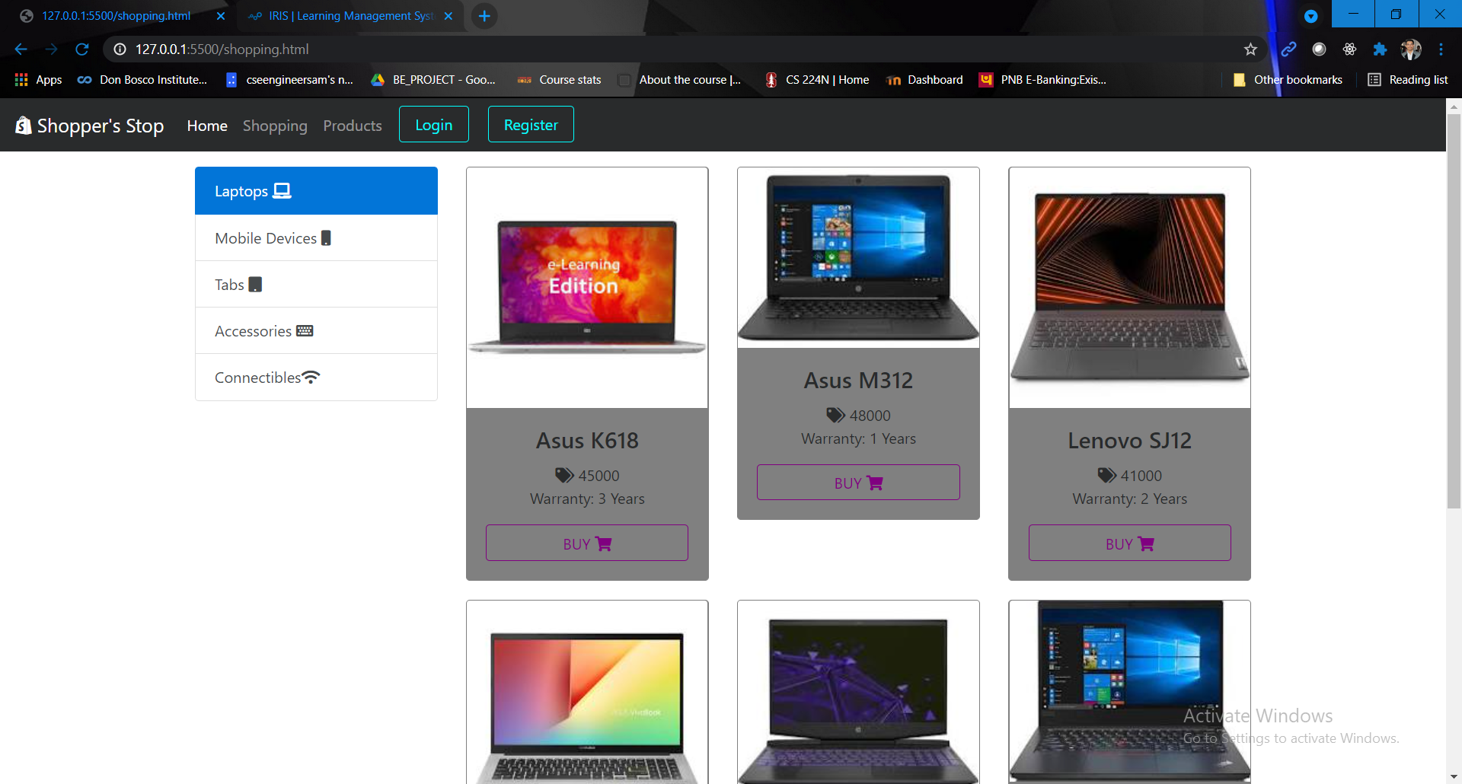

**Table using bootstrap**

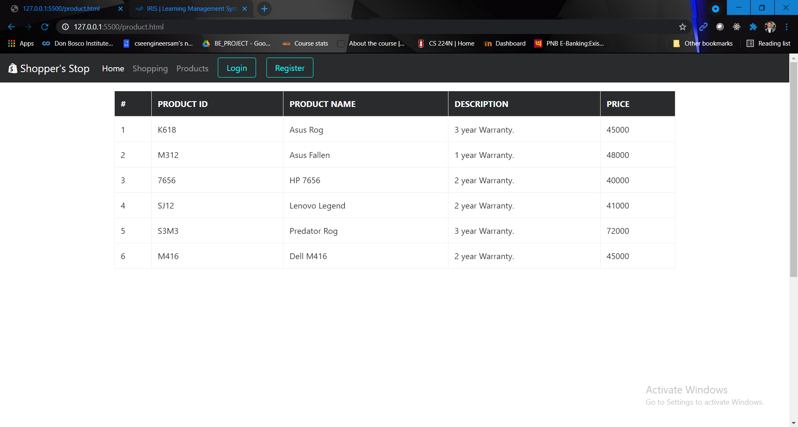

**Bootstrap font control to set font size**

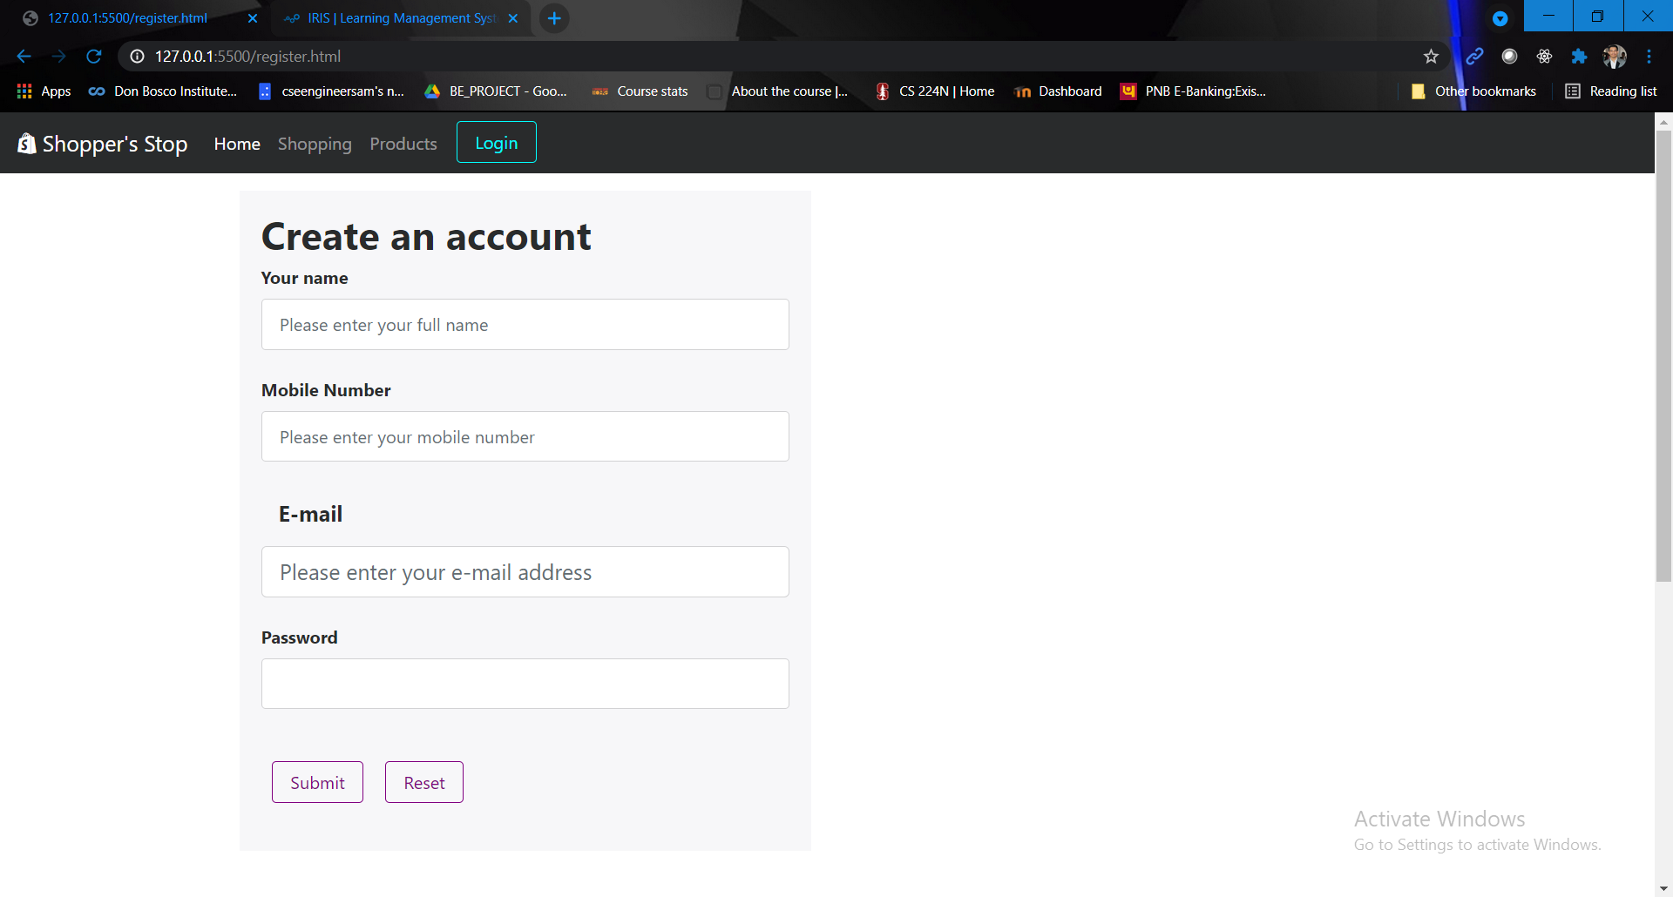

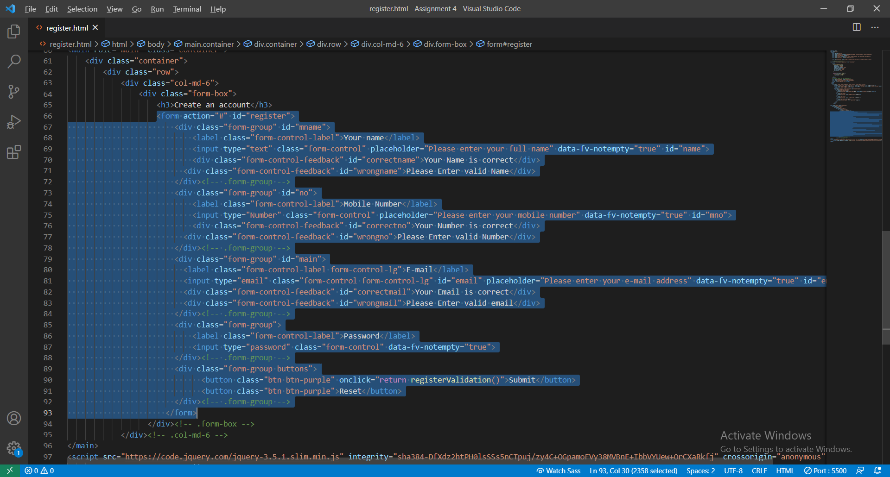

**Customized styling using bootstrap and scss**

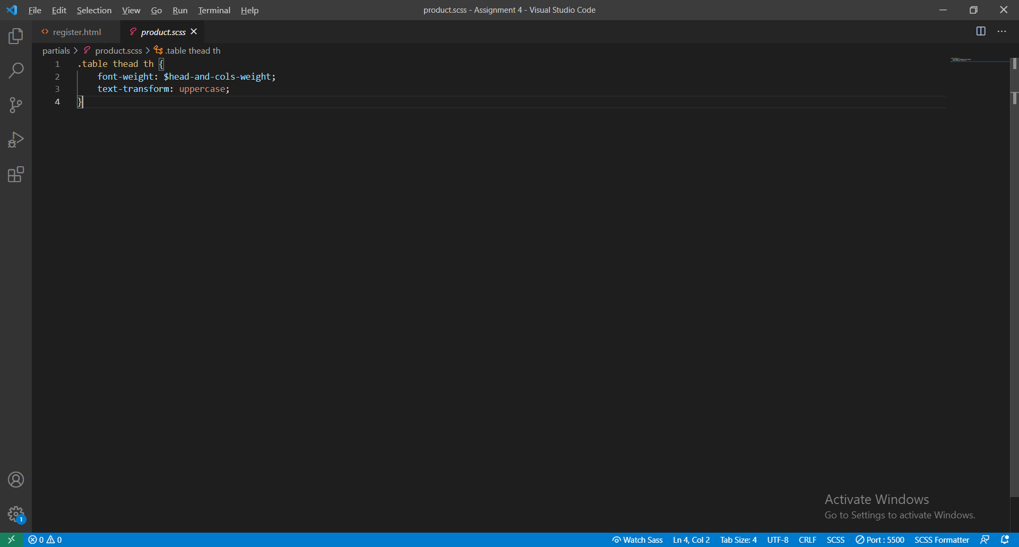

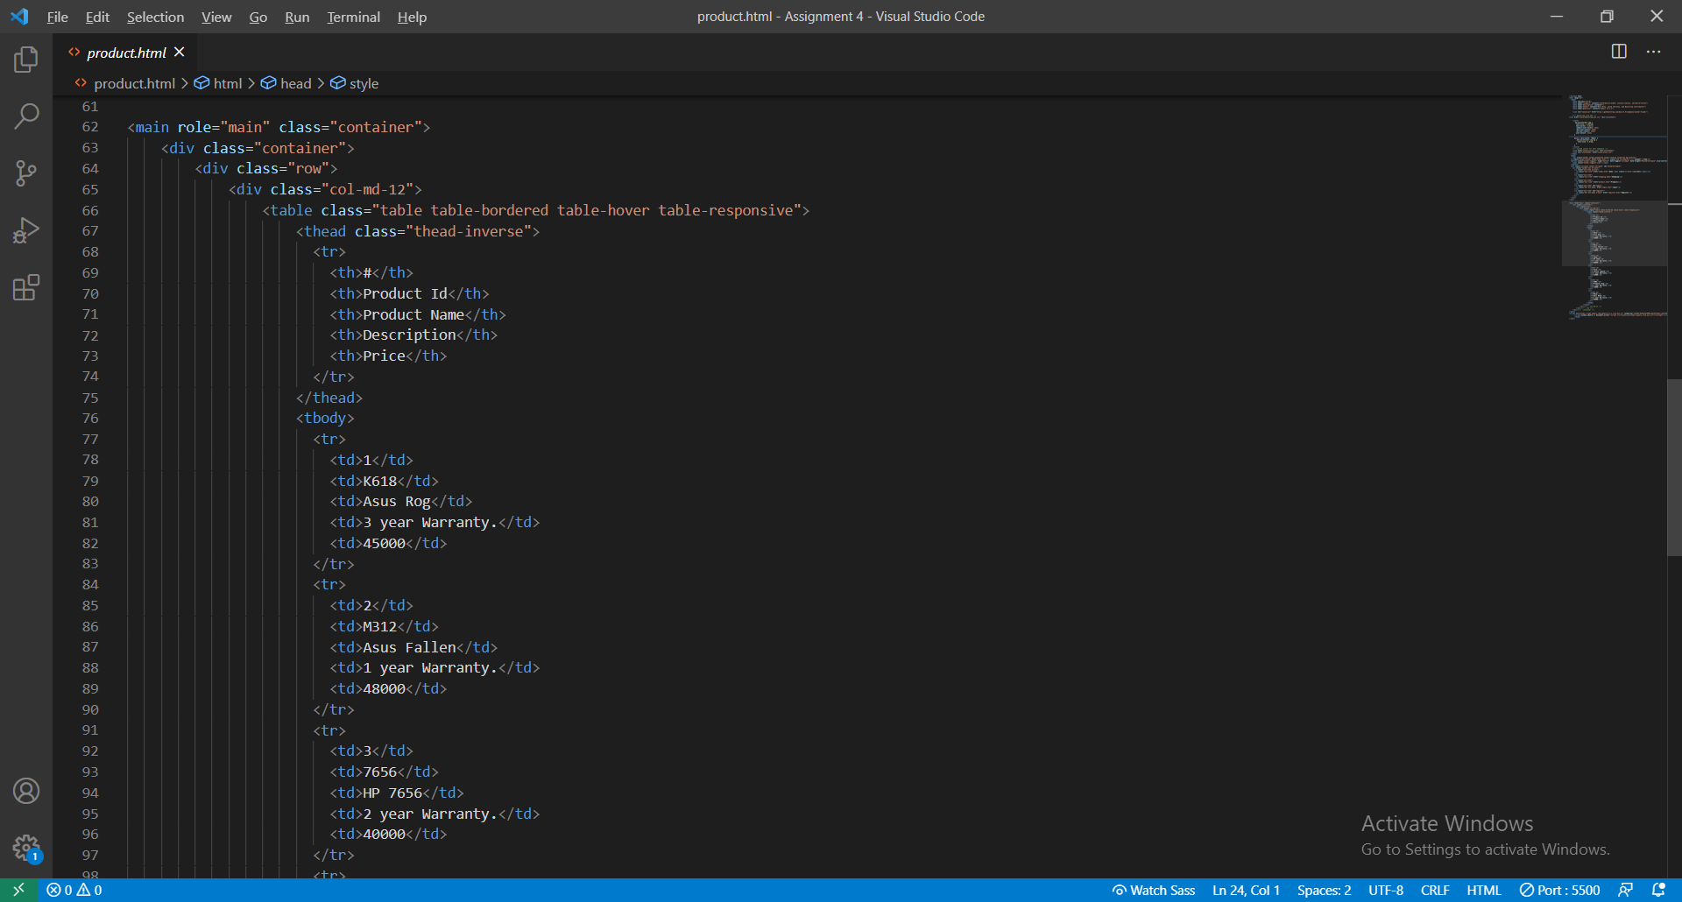

**Mixin file**

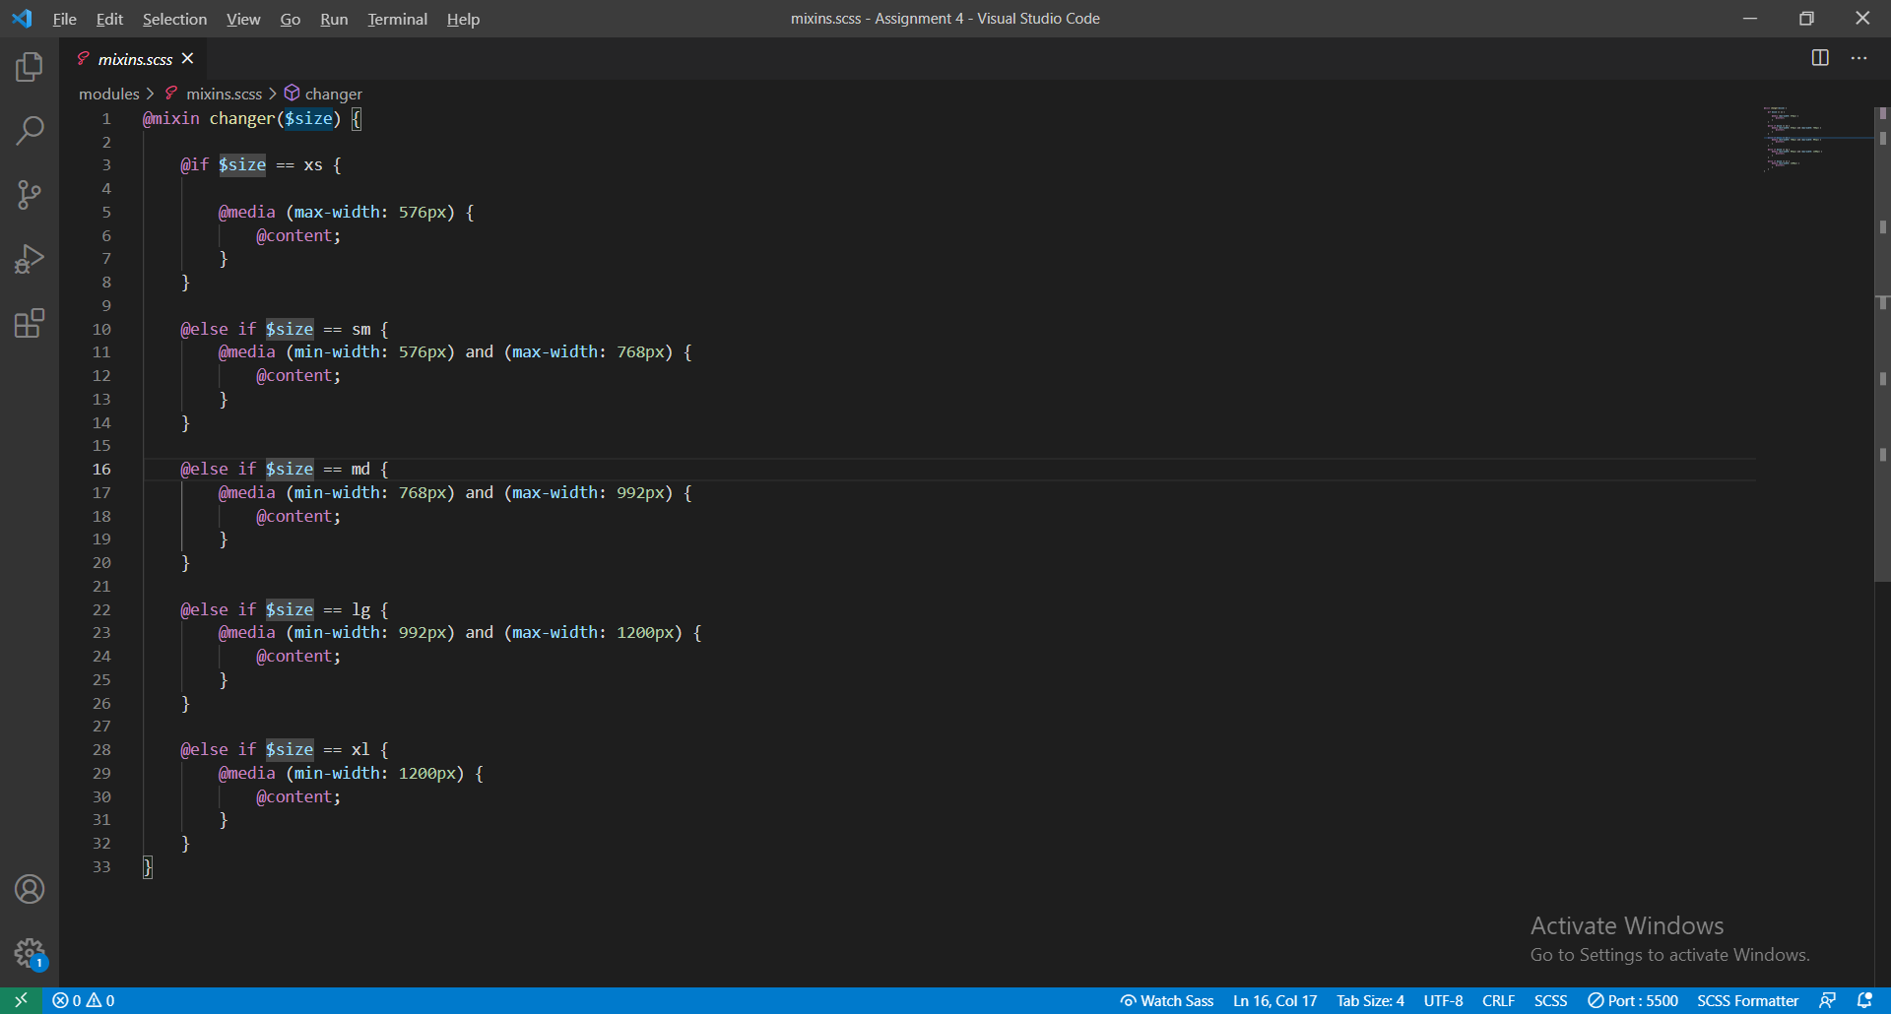

**Creating style.css file using koala**

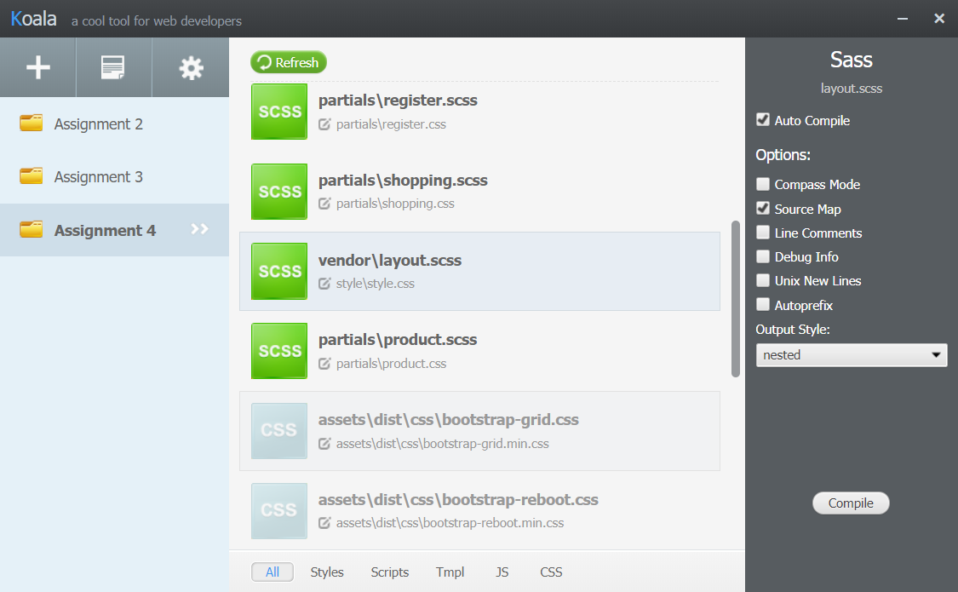

**Project folder structure**

